About Web Graphics
If you've been studying the HTML and CSS tutorials on this site, you will know how to embed a graphic image into a web page. In HTML you use the img tag, combined with the path to the image. In CSS you can specify a background image to appear on an element's background. To do this in CSS you use the background-imageproperty.
Both the HTML and CSS tutorials assume that you already have an image located on the Internet somewhere. This tutorial will show you how to create the actual image .

Examples of Web Graphics
Before we start creating our own graphic, lets look at some examples of web graphics.
Logo |  | Logos are one of the most common uses of web graphics. Most websites have a logo on every page. Logos are usually created using illustration software, such as Adobe Illustrator, then exported to GIF format.
Photo | 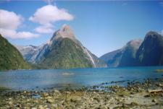 | Photos are becoming increasingly popular too, especially with so many digital cameras and camera phones available these days. Photos are usually either scanned into the computer, or imported directly from a digital camera. Once the photo is saved on the computer, you can make adjustments, re-size it, and then save it in JPEG format.
Icons |  | Icons can help a website look more professional, as well as help users quickly identify the purpose of a link. Icons are usually created using illustration software, such as Adobe Illustrator, then exported to GIF format.
Decorative Image |  | Decorative images are often used to do the bits that HTML and CSS can't do. For example, diagonal lines and rounded corners. Decorative images are also commonly used for repeating backgrounds on web pages.  Depending on the image, a decorative graphic can be created using illustration software such as Adobe Illustrator, or image editing software such as Photoshop or GIMP. It is then exported to GIF format.

Web Graphics - Properties
Most browsers provide you with an easy way to view the properties of any graphic on the web. The following example demonstrates how to do this using Firefox on a Windows computer:
- Load a web page with a graphic
- Right click on the graphic, and select "Properties":
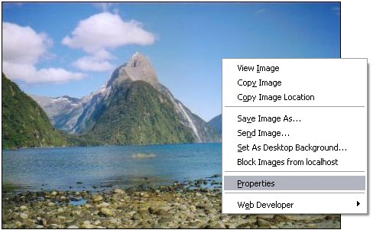
- You should now see the properties of the image:
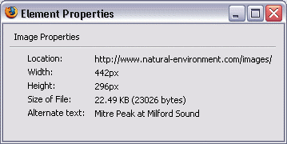
- Sometimes the image path is too long to fit in the window. In this case, depending on your browser, you may be able to click and drag the window to make it wider.

Displaying Web Graphics
Once an image has been created, it needs to be uploaded to a web server so that you can display it in your web pages. These are the steps you need to take in order to get a graphic to display on your website:
- Create the graphic
- Save it in a web format
- Upload it to a web server
- Embed the graphic into your web page (using HTML or CSS)

Graphics Software
If you want to create graphics for your web page you'll need some form of graphics software. Depending on the graphic you need to create, you will need eitherillustration software or image manipulation software, or both.

Image Manipulation Software
An image manipulation program (also referred to as a "photo editor"), is normally used to modify existing images. It can also be used to create images, but there are some types of images that are much easier to create using illustration software. Image manipulation software is perfect for touching up and resizing photos.
Adobe Photoshop is generally regarded as the industry standard when it comes to image manipulation software and is used by many professional design studios. Paint Shop Pro is also another popular package.
If you'd prefer free software, try GIMP. GIMP is a great graphics package and is similar to Photoshop. The examples in this tutorial use GIMP.
To learn more about GIMP, check out the GIMP tutorial.

Illustration Software
Illustration software is normally used for creating illustration style images. Examples include logos, icons, decorative images, and illustrations.
Adobe Illustrator is a leading illustration package used by professional design studios around the world. Xara Xtreme is another popular package.
If you don't have the money to pay for a program like Illustrator or Xara Xtreme, try DrawPlus by FreeSerifSoftware. DrawPlus is free as long as its for your own personal use.

Vector versus Pixel Based Software
Probably the biggest difference between illustration software and photo editing software is that one is vector based and the other is pixel based.
Illustration software is vector based. Without going into the technical details, one benefit you get from this is that you can scale your images up without the image deteriorating. With pixel based images, if you increase the size of the image, it gets all "pixelated". You may have seen this happen occasionally with images - it becomes blurry and the lines tend to look quite jagged.
Pixel based software (i.e. photo editors) also have their benefits. In particular, photo editors enable you to do some amazing things with photos. You can zoom right in and change colors pixel by pixel - something you can't do easily with vector based software.

Which One?
You may only need to use one of the two types of graphics software. This will depend on what type of graphic you need on your website. If you only want to touch up or resize photos, download GIMP. If you want to create a logo, or some sort of illustration, download DrawPlus. If you're not sure, why not try them out anyway. That way, you'll get to see the different options that each one offers.

Professional Designers
The most popular design software among professional web designers would have to be the Adobe suite of design products. When you apply for a job in the web design area, you will want to have these products on your resume. Fortunately, Adobe has included them in one product, so you don't need to go around downloading several different pieces of software. It all comes under the "Creative Suite" package.
If you plan to have a career in the field of graphics, you should download Adobe Creative Suite. This professional software package includes Photoshop, Illustrator, Dreamweaver, Flash, Firewoks, and many more.

Photo Editors
Although typically known as "image manipulation software", photo editors are probably referred to as such due to their common usage - editing photos. Photos aren't all you can edit, but this is where image manipulation software excels.

Special Effects
Most (if not all) pixel based image editing programs will provide you with a range of "filters" that you can apply to your images. Filters provide a quick way of adding special effects to your images. Here are some examples:
The original photo:  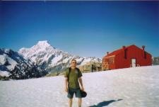 | Applying a "lighting" effect:  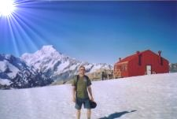
Applying a "canvas" effect:  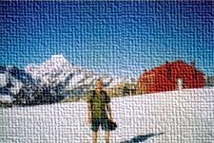 | Applying a "mosaic" effect:  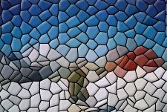

Superimposing
You can use photo editing software to "cut" a person or thing away from it's background and place it into a different setting.
Seen this character before?  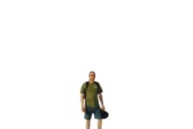 | Seen this character before?  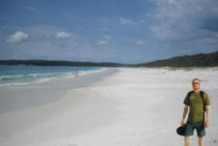
Seen this character before?  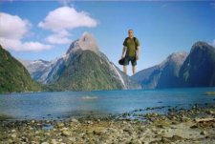 | Seen this character before?  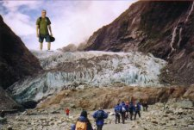
Photo editors are great for doing this sort of thing. The easiest way to "cut" someone or something away from its background is to use "paths". Paths enable you to draw around the person/thing, then turn that path into a "selection". Once you have it as a selection, you can copy/paste that selection (and everything within it) into another photo.

Resizing Photos
Resizing photos is probably one of the most common tasks done using a photo editor. Reasons you might want to resize a photo (or other image) could include:
- Your website design/layout requires it. For example, the original image might be too big to fit in the spot you'd like it to.
- You want to create a "thumbnail" which, when clicked on, leads to a larger version of the same photo.
- You want to speed up download time of your website (i.e. your website loads too slow because of the large graphics).
Any photo editor will provide you with a "Scale Image" option from the menu:
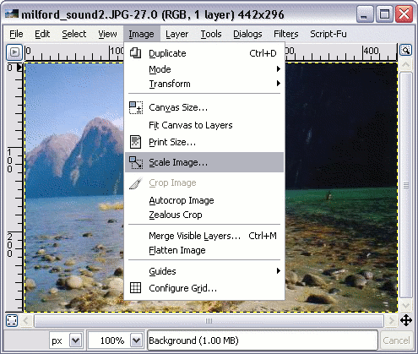
Using a photo editor called "GIMP", the above selection leads to the following dialog box (which enables you to choose how you want the image to be resized):
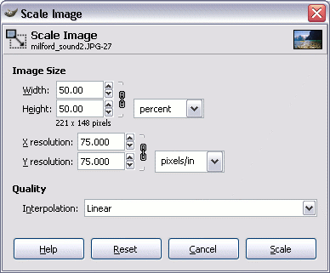
Caution: Note that resizing pixel based images upwards results in loss of quality. To avoid this, you need to ensure that the original photo/image is as big or bigger than you need it to be. Therefore, you should really only resize your photos to be smaller than the original (unless you like the "pixelated" effect).
Caution 2: Most photo editors have a default setting of "constrain proportions" (in the screenshot above, this is in the form of a chain ).
You can choose not to constrain proportions by clicking on the chain. This results in a broken chain . This means that you can specify a height and width without one affecting the other. By doing this, your image could end up looking skewed like this:

Illustration Software
The previous lesson demonstrated some of the common uses of photo editors. Photo editors are great for editing photos, Illustration software, on the other hand, is great for creating and modifying illustrations. Illustrations can include anything from a simple logo to a cartoon, or even a complex portrait or landscape drawing.

Illustrations
Cartoon illustrations like the one below are a perfect example of what can be done using illustration software. This example was actually done using the "Backdrop Wizard" in Serif DrawPlus. Wizards are great if you're not artistically inclined, but there's nothing like being original!
Example:
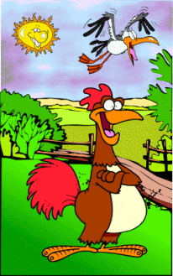

Logos
Logos can help a company create its own "identity". A good logo will be memorable - customers (or potential customers) are able to recognise a company just by looking at its logo. A logo isn't just for companies either. Any good, recognizable brand will have its own logo.
Example:

Banners
Banners normally appear at the top of a page and communicate to the reader what the page is about. Banners can be large or small, although, they are usually significantly large enough to stand out as the banner. This example was created using the "Banner Wizard" in Serif DrawPlus.
Example:


Posters
Even though this is a "web graphic" tutorial, illustration software is not limited to the web. You can use illustration software to create your own posters advertising anything you like. This example was created using the "Poster Wizard" in Serif DrawPlus.
Example:


What Does Illustration Software Look Like?
Most illustration software applications provide similar user interfaces. You have your worksheet, which contains your "page" in the middle. You have a number of toolbars for doing things like adding color, text, lines etc. You also have options for creating a shape, such as a rectangle, circle, cube, and more.
You can also import images from other applications. This allows you to transfer your images between illustration software and a photo editor. You can usually copy/paste items between the different types of packages too, which is quite handy. After all, who says you can't do illustrations over the top of a photo? In fact, many graphic designers do just that.
The following screenshot is taken from Serif DrawPlus. You'll notice that the "Shapes" menu is extended (this allows the user to add a shape to the drawing):
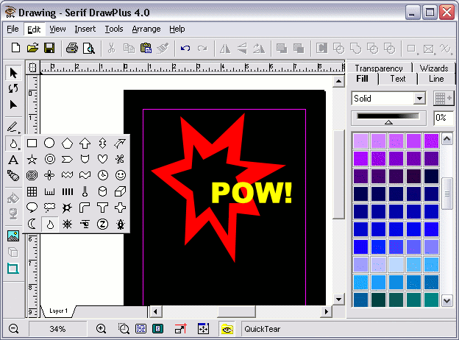

Exporting To Web Format
Most (if not all) web browsers rely on graphics being saved in either JPEG format or GIF format. PNG format is also typically accepted, but you might have problems displaying PNG in some.
What this means for those of us who build web pages, is that we have to make sure we save our images in the right format. As long as your image is in GIF or JPEG format it should be displayable, however, your images will look much better if you know which format to choose (i.e. GIF or JPEG).
JPEG is a format that suits images with lots of colors such as photos. GIF is better for images with less colors and especially if they're flat colors. Therefore, images are great for logos, cartoons, fancy text etc. To learn more about this, check out the GIF vs JPEG article.

How to Export to GIF/JPEG Format
Graphics software usually provide you with an "Export" option from the file menu. This option allows you to export the image to a different format, for example GIF format.
- Select "Export" from the file menu:
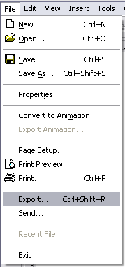
- Name your image, select a format, then click "Save":
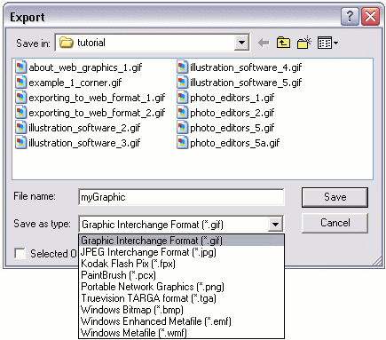

"Save As" Web Format
Some graphics software, especially photo editors, allow you to "Save As" straight to a web format.
- Select "Save" from the file menu:
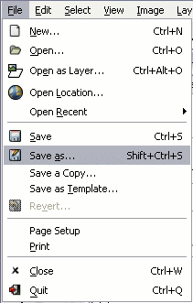
- Name the image. This example uses a photo editor called "GIMP". GIMP allows you to set the format by giving it the appropriate file extension (.gif for GIF and.jpg for JPEG):
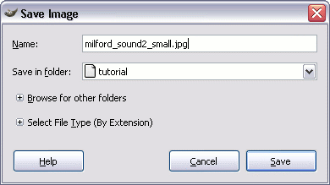
- Further options. In this case, we're saving in JPEG format. When saving as JPEG, we get the option of choosing its quality. The higher the quality the larger the file (the longer the download time):
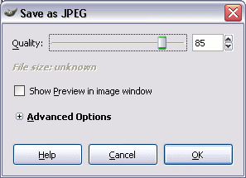

Uploading Images to the Web
So you've created your images, exported them to either GIF or JPEG format. Now you need to upload them to the web!
The method you use here will depend on whether you have a web hosting account with a hosting provider. If you do, you probably know how to upload your images - the same way you upload any other file. If you don't have a hosting account, its time to get one!

Hosting Providers
Hosting providers provide a service where you (the customer) can upload your files to their (the hosting provider) web servers. Once you've uploaded your files, they are available on the web. You can access your files (including your images) by typing the full URL of the file (i.e.http://www.hostingprovider.com/yourdirectory/yourfile.gif).
Methods for uploading files will depend on your hosting provider but generally, you will be able to use an FTP client, and/or your web host might provide you with a control panel that allows you to upload your files.
There are free hosting providers out there, but be careful. Make sure you keep copies of all your images - free services are particularly prone to going out of business. Web hosting is so cheap these days, that it can be worthwhile spending a few dollars per month for a reputable hosting provider.
If you need to find a hosting provider, try our partner site ZappyHost. ZappyHost includes some of the best prices on the web. If you prefer to shop around, here's a list of hosting providers.

Other Methods
Depending on your situation, you might encounter other methods of being able to upload your files to the web. For example, your mobile phone might enable you to upload straight to a blogger.com account. Either way, you are effectively transferring files from your local computer/phone, to a remote web server which is connected to the Internet.

Embedding Images into a Web Page
Once you've created your image, saved it as either GIF or JPEG format, then uploaded it to a web server, you can embed it into a web page.
Embedding an image into a web page is done using HTML. HTML has a special tag for this - the <img> tag. Using the <img> tag, you can embed any image on the Internet.
Here's an example:
Code | Result
 | 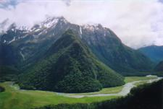
You can learn more about HTML and images with the HTML images lesson of the HTML tutorial. You might also be interested in image maps

Height and Width
The <img> tag allows you to provide a width and height. These are optional. If you do use these attributes, you should use the exact dimensions of the actual image. Changing this doesn't change the actual download size of the image - it just forces a larger/smaller image into a different space. If you need to change the size of an image, for best results, resize it in your photo editor or illustration package.

Height & Width for Mobile Devices
Although the height and width attributes can be useful, they can also cause problems if the user's screen is not as wide as the image. For example, if a user views your web page using a mobile device, they might have to scroll sideways to see the whole image. To overcome this issue, you can use the CSS max-width property.
The CSS max-width property allows you to specify a maximum width (for example, max-width:100%). By specifying a max-width of 100% or less, the image won't mess up the layout like it could if you had specified an absolute size for the image. If the actual image is wider than the screen, it will be scaled down until it is 100 percent (or however much you specify) of the size of its containing box. So, assuming the containing box is narrower than the screen width, the image won't push out wider than the screen.
If you choose this method, you cannot use the width and height attributes (because they will override your max-width settings). You should not use any height settings (such as max-height) either, as they could cause the image to skew. By leaving the height properties out of it, the image will rescale proportionally. In other words, the browser will work out it's correct width and height dimensions if you only provide max-width.

Background Images
You can use the CSS background-image property, or if you prefer, the background property to display a background image. The image could be displayed on the background of any HTML element - background of the whole page, a table cell, a div element etc.
Example of the CSS code for displaying a background image:
Code
You can learn more about CSS background code with the CSS background code lesson of the CSS tutorial.

How to use a Scanner
You might find yourself in the situation where you need to scan a photo before you can use it on your computer. You'll need to do this if you only have a hard copy of the photo (i.e. not a digital copy).
Before you scan a photo, you need the following equipment:
- A scanner
- Scanner software

The Scanner
Scanners typically come in two types - flatbed, and sheetfed. A flatbed scanner is one where you to open the lid and place the photo on the glass platen. Flatbed scanners allow you to scan all sorts of things such as paper, photos, leaves, fabric etc. A sheetfed scanner is one where you feed the photo into the scanner via a slot. A sheetfed scanner is more limited to what you can scan as it needs to fit into the slot.

The Scanner Software
Most scanners come with their own software. This usually contains the scanner driver as well as a basic image editor to assist you with scanning and touching up your photos. You will need to install the software before you use the scanner for the first time. This is usually very easy - just run the CD that came with the scanner and follow the prompts.
As long as the scanner software has been installed, you can also use your own software to initiate each scan. Most photo editing applications allow you to access the scanner via their "File" menu. Examples of photo editing software include Adobe Photoshop, Corel Paintshop Pro, and The Gimp.

Scanning a Photo
Assuming your scanner has been set up and it's connected to your computer/network, the actual steps you use to scan a photo (or anything else) will depend on your scanner. Typically, it will be one of the following:

Method 1 - Automatic
Some scanners will automatically start scanning as soon as you place the photo in. It doesn't get much easier than this! Once it has been scanned, the prompts usually make it easy for you to touch up the image and save it.
- Position the photo in the scanner
- The photo will automatically be scanned (or previewed) and will appear within the scanner software. From here, things should be quite intuitive - just follow the onscreen prompts.

Method 2 - Semi-Automatic
Similar to the first method. The only difference is that you need to push the "Start Scanning" button on the scanner itself before it starts scanning.
- Position the photo in the scanner
- Press the "Start Scanning" (or similar) button on the scanner.
- The photo will automatically be scanned and will appear within the scanner software. From here, things should be quite intuitive - just follow the onscreen prompts.

Method 3 - Scanning via the Scanner Software
Scanner software is usually quite intuitive - all you need to do is open it up and follow the prompts.
- Position the photo in the scanner
- Open the scanner software (i.e. via an icon on your desktop or from the "Start" menu depending on your computer).
- Once you've opened the scanner software, it will usually give you some options such as "Scan Photos", "Preview" etc. Follow the prompts and you should be OK. If you make a mistake it won't matter - just delete the first scan and start another scan.
- Once you select "Start Scanning" (or similar), the photo will automatically be scanned and will appear within the scanner software. From here, things should be quite intuitive - just follow the onscreen prompts.

Method 4 - Scanning via your Graphics Software
This is the most involved out of all methods. Once you've done it a few times, you'll realize that scanning photos is actually quite easy.
Generally, to initiate a scan, go "File > Acquire > TWAIN" and select your scanner from a list. From there, it's usually quite intuitive.
Because this method is a bit more involved, here's a detailed example. In this example, I'm going to use a photo editor called "The GIMP" to initiate the scan. These steps are pretty typical of what you need to do when scanning via graphics software.
Now, assuming you have your graphics software open, do the following (or similar):
- Via the "File" menu, select "Acquire", then "TWAIN". If you don't see these options, you might need to select "File > Scanner > Import" or something similar. The terminology sometimes changes between software, but they all do the same basic thing.
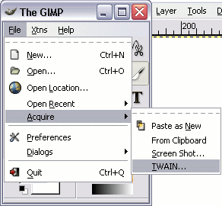
- Select the scanner you're using from the list. You may only have one scanner - just select that. As you can see, I have two scanners. If you don't see your scanner here, it may be that you still need to install the driver. Check the CD that came with the scanner.
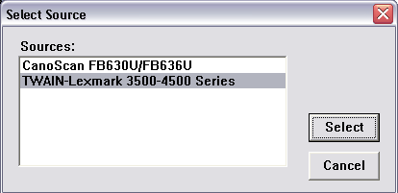
- At this stage, my graphics software has accessed the scanner software using the TWAIN standard. As you can see, the scanner software makes it pretty easy from here on. You can click "Preview" to check that your photo is positioned correctly etc. You can also change the scan quality. Note that if you're only going to use the image on the web, 72 dpi is fine. Having said this, by increasing the resolution, the more detail you capture (and the bigger the image becomes). Higher resolution will often result in a much larger file size, so if you use anything other than 72 dpi for the web, check the file size once you've scanned it.
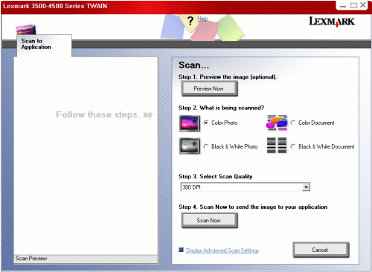
- So, after clicking the "Scan Now" button, the scanner starts making noises, and after a few seconds, the image pops up on my screen. Note that this image has been transferred to my graphics software (The GIMP).
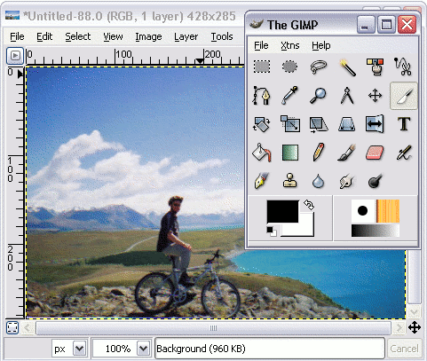
So, now that the photo has been scanned, you can save it just as you would any other file (i.e. via the "File > Save As..." menu). Once you've saved it you don't need to do anything more. Having said this, you can make changes to the image as you wish. For example, you might want to resize it, use a filter such as "sharpen", "despeckle" etc.
If you intend to use your photos on the web, you'll need to make sure you save it in the correct format. To learn about saving images for the web, check out Exporting to Web Format.

